
Company
Logotype

Cone Beam Computed Tomography- Report



Porur Dental X-rays & CBCT

Patient Name : Mrs. Mangai | Date of Report : 12.05.2024
Age/ Gender : 82 years/ Female | Region of Interest : CBCT Full Skull
Referring doctor: SV Dental Care | Indication : Implant assessment
Clinical Notes: Nil
PATIENT INFORMATION

CBCT- Full Skull provided
CBCT – IMAGE DETAILS

RADIOGRAPHIC INTERPRETATION

- Completely edentulous maxillary and mandibular arch.
- The alveolar ridge in relation to the maxillary and mandibular alveolar ridge is present with resorptive changes and reduced height alveolar ridge.

IMPLANT ASSESSMENT

 | 11 region | 12 region | 13 region | 14 region | 21 region | 22 region | 23 region | 24 region
Sub-Crestal | 2.2 | 2.2 | 1.6 | 1.3 | 1.4 | 1.3 | 1.7 | 1
Distance between the alveolar ridge and Floor of the Nasal cavity (in mm) | 4.8 | 5.8 | 5.2 | 5.3 | 5.7 | 5.6 | 4.9 | 6.8

 | 15 region | 16 region | 17 region | 25 region | 26 region | 27 region
Sub-Crestal (in mm) | - | - | - | - | - | -
Distance between the alveolar ridge and floor of the maxillary sinus (in mm) | 1.3 | 1 | 0.9 | 0.9 | 1 | 1

 | 31 region | 32 region | 33 region | 34 region
Sub-Crestal (in mm) | 6.3 | 6 | 7.2 | 5.4
Mid- Crestal (in mm) | 7.1 | 6.9 | 8 | 7
Distance between alveolar ridge and the inferior border of mandible (in mm) | 12.4 | 13.2 | 12.8 | 12.1

 | 41 region | 42 region | 43 region | 44 region
Sub-Crestal (in mm) | 6.2 | 5.7 | 6.2 | 8.3
Mid- Crestal (in mm) | 6.5 | 6.9 | 7.9 | 8.4
Distance between alveolar ridge and the inferior border of mandible (in mm) | 11.3 | 12.6 | 11.5 | 9.8
 | 35 region | 36 region | 37 region
Mid-Crestal (in mm) | 7.8 | 8.2 | 10.3
Distance between alveolar ridge and the inferior border of mandible (in mm) | 11.7 | 11.1 | 9.6
Width buccal to the Inferior alveolar nerve canal (in mm) | 2 | 3.1 | 4.2
Width lingual to the Inferior alveolar nerve canal (in mm) | 2.5 | 4.2 | 4.6

 | 45 region | 46 region | 47 region
Mid- Crestal (in mm) | 7.5 | 8.3 | 9.3
Distance between alveolar ridge and the inferior border of mandible (in mm) | 8.9 | 7.9 | 8.7
Width buccal to the Inferior alveolar nerve canal (in mm) | 2.8 | 4.6 | 4.8
Width lingual to the Inferior alveolar nerve canal (in mm) | 2.2 | 2.2 | 2.2

RADIOGRAPHIC IMPRESSION

Partially edentulous maxillary and mandibular arch with resorptive changes of alveolar ridges.

Kindly correlate with clinical findings


IMAGES FOR REFERENCE

RECONSTRUCTED PANORAMIC VIEW

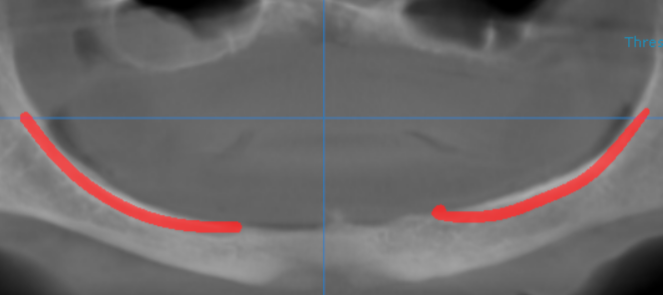

3-DIMENSIONAL VIEW

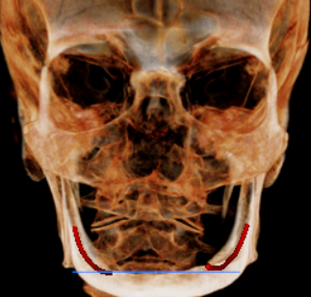

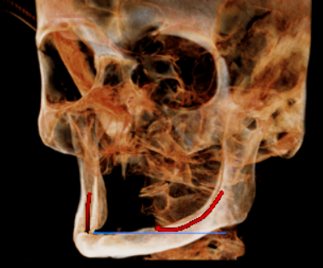
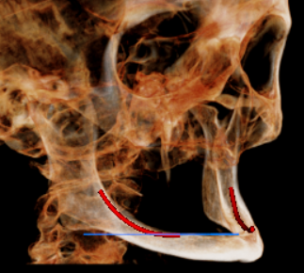

CROSS SECTIONAL VIEW

11 region | 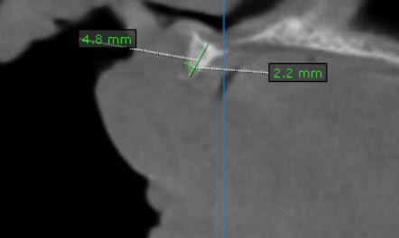
12 region | 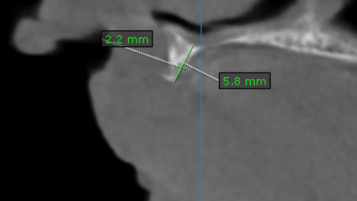
13 region | 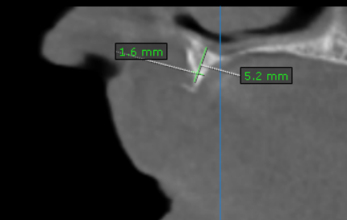
14 region | 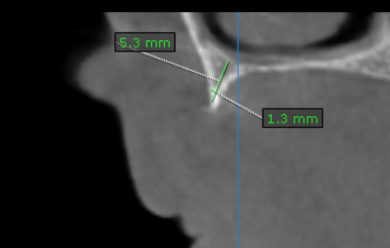
15 region | 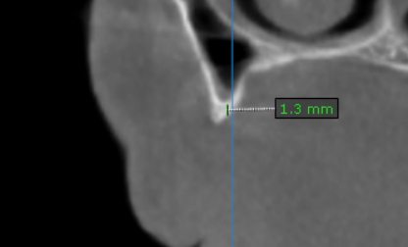
16 region | 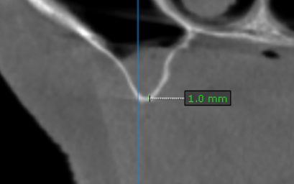
17 region | 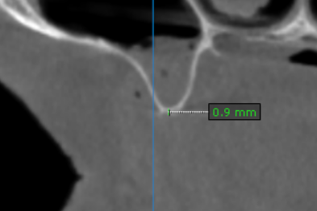
21 region | 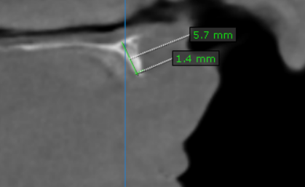
22 region | 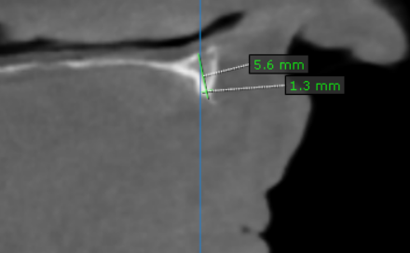
23 region | 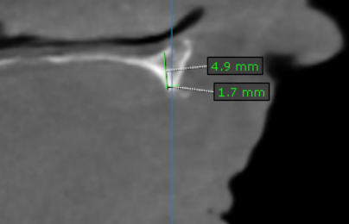
24 region | 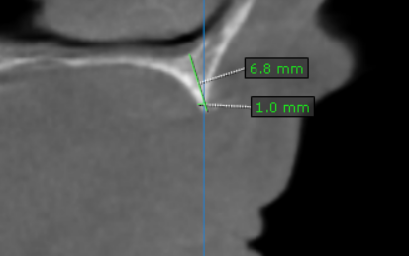
25 region | 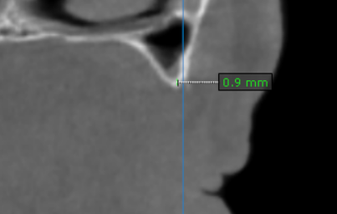
26 region | 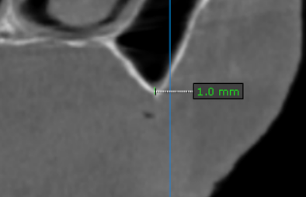
27 region | 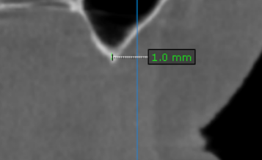
31 region | 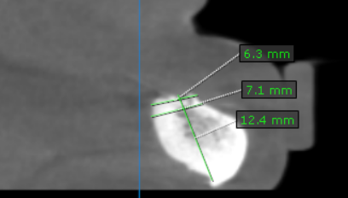
32 region | 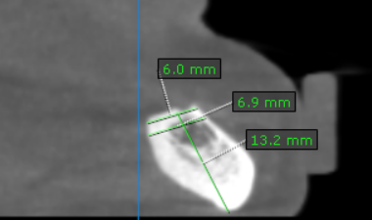
33 region | 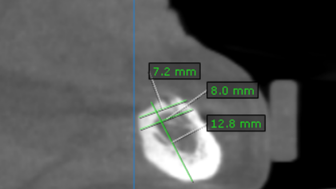
34 region | 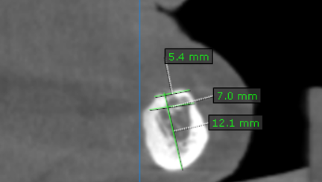
35 region | 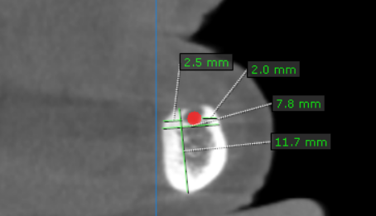
36 region | 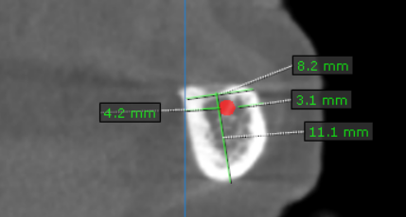
37 region | 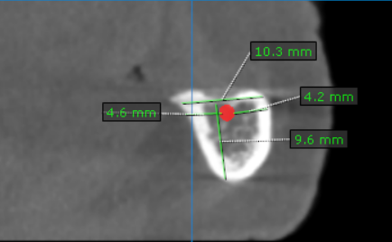

41 region | 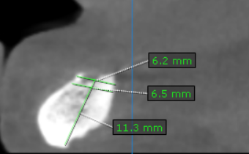
42 region | 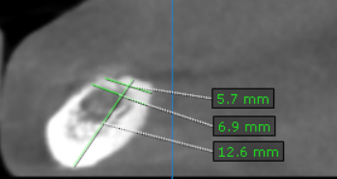
43 region | 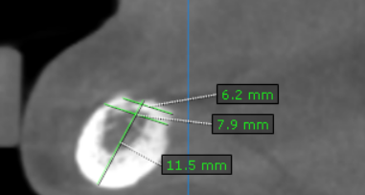
44 region | 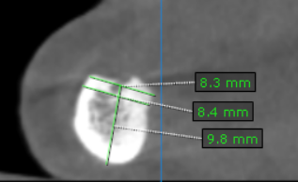
45 region | 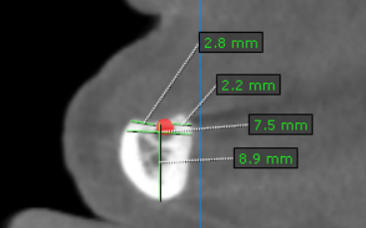
46 region | 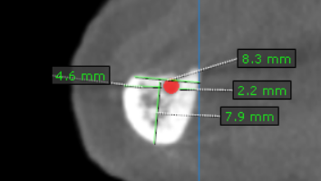
47 region | 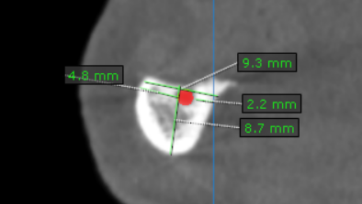

**** End of report ****

